User Account Creation Menu (Forms):

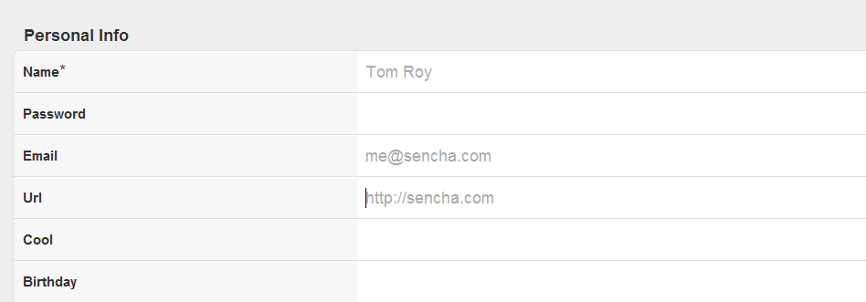

Possible Icons (Icons):

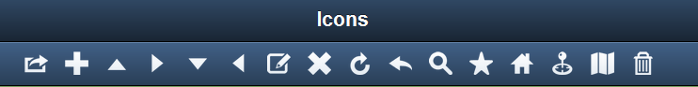

Drop Box/Swipe to Area and Files for Dropping (Drag and Drop):

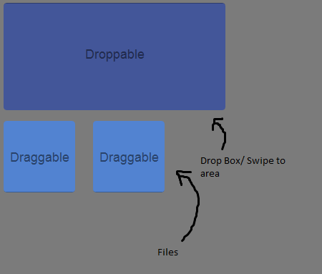

Menu (Bottom Tabs):

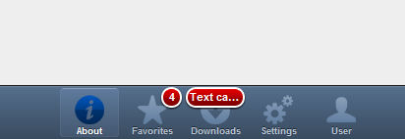

Contacts Menu (List):

